5.81: The friction force on block A is 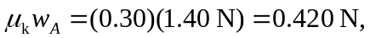 as in Problem 5-68. This is the magnitude of the friction force that block A exerts on block B, as well as the tension in the string. The force F must then have magnitude

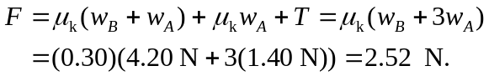

Note that the normal force exerted on block B by the table is the sum of the weights of the blocks.

